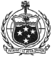
OFFICE OF THE PACIFIC GAMES 2019
Faleata Sports Complex
Tuanaimato
Email: info@samoa2019.ws

30 January 2019
Media Release

Team Tahiti visits Samoa Ahead of the Games

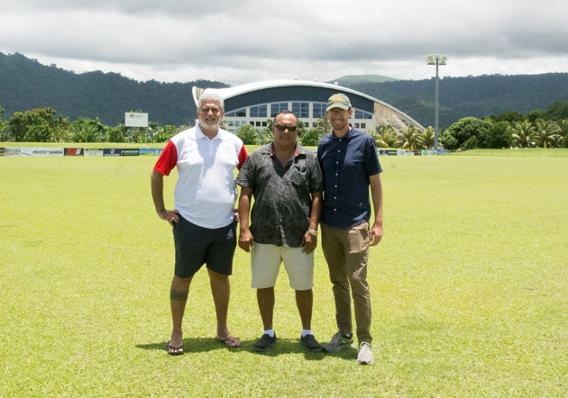
(L-R) Mr. Michel Sommers (Treasurer of the Olympic Committee of French Polynesia) and Mr. Teva Bernadino (Head of Tahitian Delegation) with Games Operations Manager Jack Smith

(PACIFIC GAMES OFFICE); The Pacific Games Office this week welcomed a delegation from the Tahitian team that are here to conduct site visits and meetings ahead of the Games.

The main reason for the visit is to garner better understanding of what Team Tahiti can expect in July. Yesterday, the Pacific Games Office team led a tour for the visiting delegation. The visit included a tour of the sports competition venues as well as the Games Village where athletes and team officials will stay.
The delegation commended Samoa and its preparations after witnessing the groundwork and progress Samoa is making in terms of preparations. The team is scheduled to depart at the end of the week.

