MEDIA RELEASE
31 May 2019

Samoa Pure Water is a Silver Sponsor for Samoa 2019 XVI Pacific Games

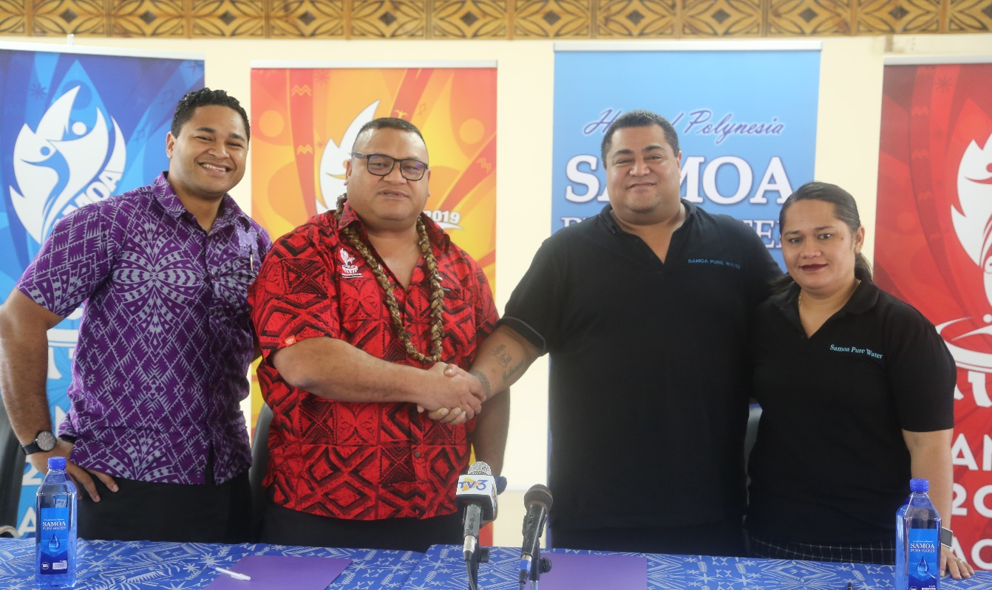
L-R: PGO Commercial Manager Kurt Fatupaito, Director of Sponsorship Tagaloa Faafouina Su’a, Tusa Victor Vaai and Tagaloa Nua Vaai at the MoU signing ceremony _{earlier today.}

(PACIFIC GAMES OFFICE); The Pacific Games Office is proud to announce Samoa Pure Water as a Silver Sponsor of the Samoa 2019 XVI Pacific Games.

The announcement was made by the Director of Sponsorship, Tagaloa Faafouina Su’a, at a brief signing ceremony this morning.

“On behalf of the Chairman, the Executive Committee, the Organising Committee and the Government of Samoa, I’d like to convey a huge Fa’afetai tele lava and thank you to Samoa Pure Water for their sponsorship.

“We wouldn’t be able to stage these Games without the support of our people, government, stakeholders and partners, so thank you once again Samoa Pure Water for your generous support,” said Tagaloa.

Tusa Victor Vaai, Chairman of Samoa Pure Water, spoke to reaffirm their support for the Games.

“We are happy to be working in partnership with the Pacific Games Office. We are even more excited because we will be able to give back to the people of Samoa and get the rare chance to promote our products and Samoa to our visitors in July.”

Samoa Pure Water is a locally owned business based in Vaitele. Their products are certified by the Ministry of Health in partnership with Scientific Research Organisation of Samoa (S.R.O.S.) and Scarab Systems Limited, a New Zealand-certified Institute of Safety Management.

The sponsorship package is valued at $200,000. Samoa Pure Water is supporting the Greening of the Games initiative which looks to reduce the amount of single-use plastic being used for the Games. Samoa Pure Water’s support will ensure that there is a constant supply of water to all athletes and officials at the Games venues.

- - - - -Ends- - - - -

For more information visit www.samoa2019.ws

For further comments or to arrange an interview, contact: media@samoa2019.ws

