OFFICE OF THE PACIFIC GAMES 2019
Faleata Sports Complex
Tuanaimato
Email: info@samoa2019.ws

28 January 2019

Media Release

Games Village preparations update

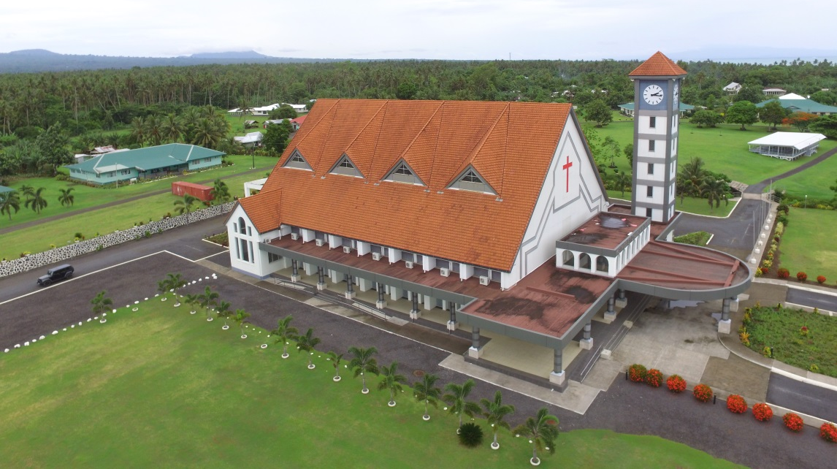
Methodist Church located at the heart of the Faleula Methodist Compound which has now been announced as the Games Village for PG2019

(PACIFIC GAMES OFFICE); In November 2018, Faleula Methodist Compound was announced as the Games Village. Over 3,500 Athletes and Team Officials are expected for the Samoa 2019 Pacific Games and preparations are underway to accommodate competitors.

Sitting on a beautiful half of a square kilometer, the Games Village is 15 minutes when driving from the main competition venues and downtown Apia. Comprised of three schools, a large church and 50+ buildings and houses, the Games Village will also feature an Athlete Centre, a Sports Information Centre and Chef de Mission Offices.

In the Games Village, Athletes and Team Officials will each have their own bed and sleeping arrangements will be in a combination of houses and classrooms. Each country will be allocated a house that can serve as a central hub for their delegation.

The Athlete Centre will house services such as banking, merchandise, a convenience store and laundry. The Sports Information Centre is set up for Team Officials to access official results and arrange training times at approved training venues.

Breakfast will be served at the Games Village for the duration of the Games. Athletes and Technical Officials will eat breakfast here at the Games Village during the games period. Breakfast will be open from 5am until 9am every day during the games period.

Due to the size of the compound, there will be an internal shuttle for athletes and technical officials to access the various areas within the Games Village. This shuttle will run during the entire official games period.

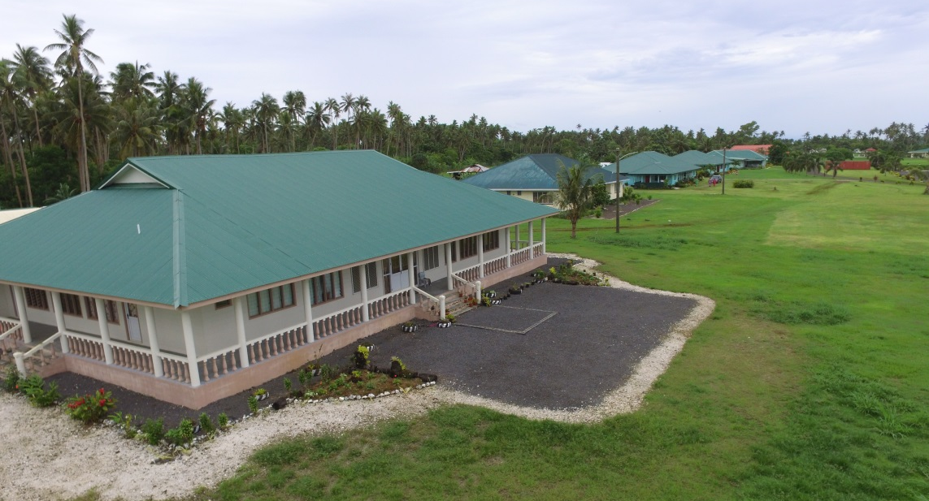
One of the many buildings within the Faleula Methodist Compound

The Games Village will be open for teams competing in the Samoa 2019 Pacific Games, Thursday 4 July – Monday 22 July 2019.

------- ENDS --------

For more information contact:
media@samoa2019.ws

