MEDIA RELEASE
15 June 2019

Federal Pacific Finance supports Samoa 2019 XVI Pacific Games

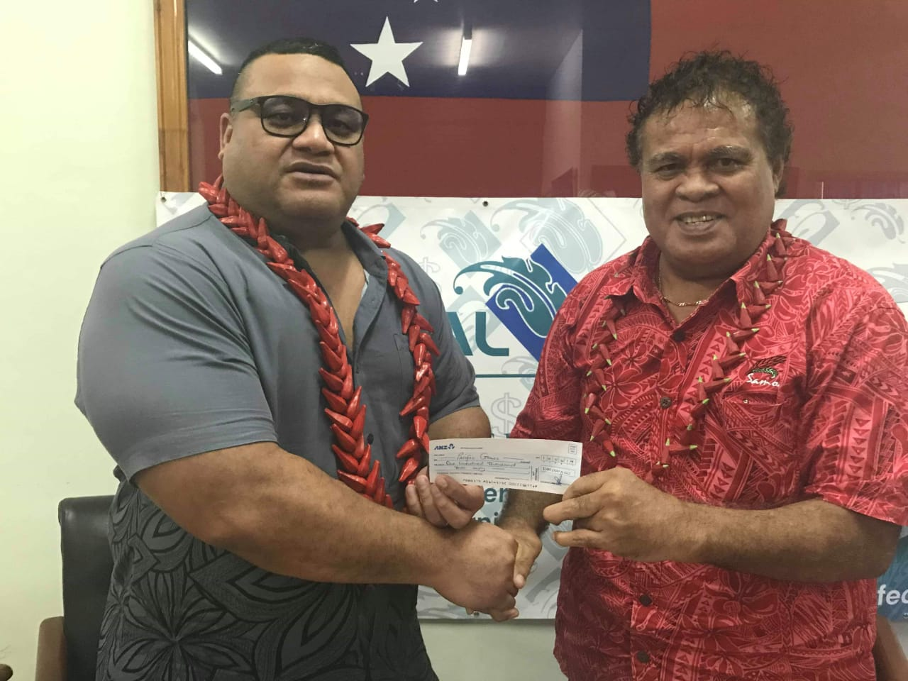
General Manager of Federal Pacific Finance, Afamasaga Opeta Siilata hands over donation for Samoa 2019 XVI Pacific Games.

(PACIFIC GAMES OFFICE); The Pacific Games Office today announced that Federal Pacific Finance has come on board as a Supporting Sponsor for Samoa 2019 XVI Pacific Games.

On-site to receive Federal Pacific’s generosity was the Director of Sponsorship, Tagaloa Faafouina Su’a.

“On behalf of the Government and the Games Organising Committee, I would like to thank the management and staff of Federal Pacific Finance for your generous donation of $100,000. Your kindness is greatly appreciated as we head closer to the beginning of the Pacific Games. May the good Lord replenish all that you have given in support of the Pacific’s biggest sporting event,” said Tagaloa.

Federal Pacific has been serving the people of Samoa for almost twenty (20) years as a local financial service provider.

The Pacific Games Office is grateful for the support provided by the people of Samoa as well as the business community towards the preparations for the Games next month.

In 22 days, Samoa will host XVI Pacific Games, and the Pacific Games Office continues to be the key focal point for all matters relating to Samoa 2019.

- - - - -Ends- - - - -

For more information visit www.samoa2019.ws

For further comments or to arrange an interview, contact: media@samoa2019.ws

